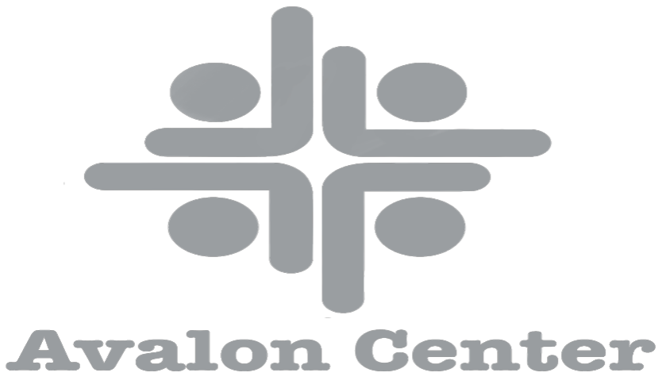

Avalon Center Lower-Level Room Policy

Purpose
The primary purpose of the Avalon Center is to provide an open space to meet the needs of the community. There is no charge to rent the room but there is a usage fee that covers the cleaning and utilities of $200 which is due to Avalon Center at the time the reservation is made.

Scheduling
Requests for the use of the event space must be submitted to the Avalon Center Office manager by emailing olivia@avaloncenter.us or calling the Charles City office phone number 641-715-1183. The usage fee must be received at the time of the reservation. Electronic reservations will be held for 3 business days to allow users to drop off usage fees at the Avalon Center. If payment is not received within 3 days, the pending reservation will be canceled, and the room will be available to be reserved by a different user. Reservations are accepted on a first-come, first-serve basis. The Avalon Center reserves the right to right to revoke permission to use the meeting room and will refund all fees paid.

Equipment
The event space is equipped with a kitchen along with a stove, and a refrigerator. The event space has tables and chairs that will be available. Two bathrooms are also available at the lower level. There is a 70 inch television available on request.

Room Use
The user may move and rearrange the tables and chairs, but the furniture must be returned to its original position
No adhesive may be used on the painted part of the walls. The user is responsible for supervising attendees, including children, while using the event space. Food and non-alcoholic beverages are allowed in the meeting room. All refreshments and food are to be provided by the user. Users must clean up the room, and kitchenette, and discard their own trash in the trash cans. No food items may be left in the fridge unless otherwise arranged with the Avalon Staff. Smoking is not permitted on Avalon Center Property, inside or outside on the grounds. No open flames such as candles are allowed. Users must comply with posted fire regulations. The fire alarm is located at the entry to the upstairs level. A fire extinguisher is available under the sink in the kitchen. After-Hours Room Use Users must enter/exit the building on their own through the back parking lot door. Users are responsible for planning for after-hours access.

Cancelations
The user will give the Avalon Center advanced notice of a cancelation. If the event space is not occupied within 30 minutes of the reserved time, it will be considered available for use by others. The organization or responsible party is responsible for notifying members of schedule changes.

Other
- The Avalon Center is not responsible for theft or damage of personal items occurring in connection with the use of the event space (Lower Level).
- Use of the event space by individuals or groups does not constitute an endorsement by the Avalon Center. Approval of event space and situations not described here will be determined by the Avalon Center Director, who is authorized to establish reasonable regulations governing the use of the event space and related fees.
- The Avalon Center name must not be used as an event sponsor (implied or otherwise) or endorsement unless permitted in writing by the Avalon Center Director. The following statement should be used on promotional materials: “This program is sponsored by __ and will be held in the “Lower-Level Event Space at the Avalon Center.”
- You are responsible for payment if any damages occur during your event. If the costs of replacement or repair exceed the deposit, the Avalon Center will bill you for the loss & damages and cleaning expenses.

The Avalon Center reserves the right to deny use of the facility to any individual or group for any reason.

Questions/Concerns contact leah@avaloncenter.us, olivia@avaloncenter.us, or 641-715-1183.

Lower-Level Rental Agreement
ORGANIZATION/ Person:

DATE ROOM IS TO BE USED:

TIME: (Allow for set up and tear down time)

NAME OF RESPONSIBLE PARTY:

TELEPHONE NUMBER:

EMAIL ADDRESS:

Please initial in the box on the left of the form to acknowledge and agree to each policy.
______The Avalon Center Lower level requires a $200 nonrefundable usage fee for cleaning and utilities for each day of use. I acknowledge that I will not be able to hold my event until I pay the user fee. The Avalon Center will receive this user fee in the following form:
______Check ______Cash _______Credit Card/Debit Card

______ An Avalon Center employee will open the building for any event and will come close after an event has finished at the time stated above.

By signing below, I acknowledge that I have read the Avalon Center Rental policy and agree to the terms listed. I acknowledge that I am responsible for any cost that may be incurred in my use of this room.

SIGNATURE: __________________________________________________ Date: ________

For use by Avalon Center Personnel Only:
Number of Attendees: _________ Date Application turned in: _______
Deposit Returned Date: ________ Staff Initial: _______

